Statistics: Study of collection, analysis, interpretation, presentation & organization of data; Numbers that summarize raw facts & figures in some meaningful way; Study of uncertainty; We need it to identify variability in data; Population: Collection of set of individuals/objects where researcher is interested in drawing conclusion; It can be finite/infinite; Collecting data from all the individuals in the population – census; Sample: Subset of population; Collecting data from a part of the population (sample) – sample survey; Survey Errors: Sampling error; Measurement error; Selection bias; Non-response bias; Coverage error; Variable: Characteristic/property of each individual in the population/sample; E.g.: AGE, GENDER; Qualitative/Attribute/Categorical: A variable that categorizes & describes an element; Ordinal: Ordered; E.g.: Satisfaction Rating, Pain Severity; Nominal: Categories aren’t naturally ordered; E.g.: Hair color, Gender, Marital status; Quantitative/Numerical Variables: “” quantifies an element; Discrete: Distance between 2 values exists; E.g.: Age in years, Marks; Continuous: Contains any value within a given range; E.g.: Temperature; Nominal Data → Ordinal Data → Interval Data → Ratio Data;
Interval Scale | Ratio Scale
Equal intervals between values
Variables can be added & subtracted. But ratio & multiplication isn’t possible | Can perform all
Can calculate mean, median & mode
True zero point – 0 doesn’t mean none | True zero point – 0 indicates complete absence of quantity
Can consider positive & negative numbers | Can consider only positive numbers
Temperature in Celsius | Age, Weight, Height
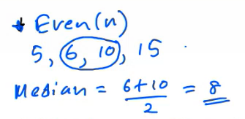
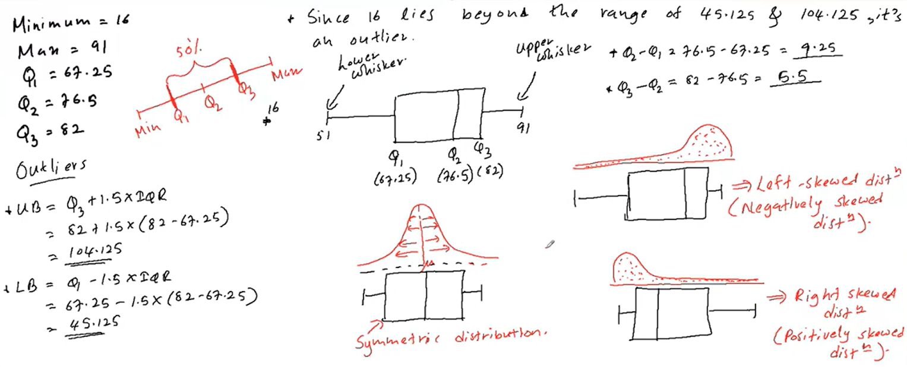
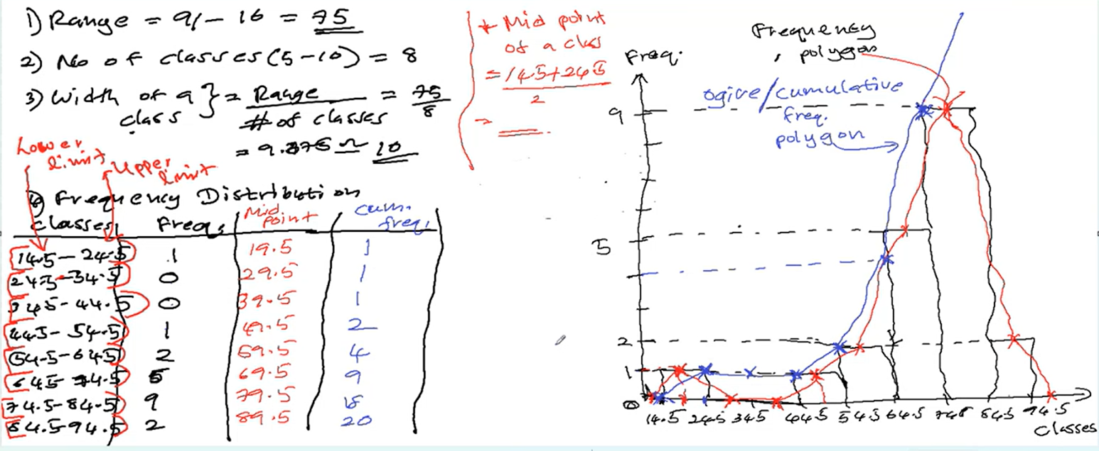
Data: Value of the variable associated w. 1 element of a population/sample; Number, word / symbol; Parameter: Describes population; E.g.: Population mean ($µ$), Population variance ($σ^{2}$), Population proportion ($P$); Statistic: “” sample; Summary characteristic value of sample; E.g.: Sample mean ($\overline{x}$), sample variance ($S^{2}$), sample proportion ($p$); Descriptive Statistics/Preliminary analysis/Explanatory analysis: Gives idea abt. behavior of data; Describes how each of the variables behave; Graphical Method: To analyze categorical & numerical variables; 1 categorical variable: Bar charts; Pie charts; One way frequency tables; 1 numerical variable: Histograms: $Range=Max-Min$; # of classes is normally between 5 – 10; $Width of a class=\left\lceil \frac{Range}{\# of classes}\right\rceil$; $Mid point of a class=\frac{Lower Limit+Upper Limit}{2}$; Box plots: $Position of Q_{1}=\frac{n+1}{4}$; $LB=Q_{1}-1.5×IQR$; $UB=Q3+1.5×IQR$; $IQR=Q_{3}-Q_{1}$; Min & Max → End point of whiskers; When drawing boxes, also calculate $Q_{2}-Q_{1} \& Q_{3}-Q_{2}$; Symmetric: Mean = Median = Mode; Positive: Mean > Median > Mode; Negative: Mean < Median < Mode; Stem & leaf plots; Numerical Method: Summarize variable into a single value; Measurements: Central tendency: Gives idea about location of data; Mean: Arithmetic Mean: Population ($μ$), w. $N$ elements ($x_{1},x_{2},…,x_{N}$) $μ=\frac{\sum_{i=1}^{N}{x_{i}}}{N}$; Sample ($\overline{x}$), w. $n$ elements ($x_{1},x_{2},…,x_{n}$) $\overline{x}=\frac{\sum_{i=1}^{n}{x_{i}}}{n}$; Geometric Mean; Harmonic Mean; Median: Not heavily influenced by extreme outliers; Most appropriate for highly skewed data containing massive outliers; Mode: Value w. highest frequency; Percentiles/Deciles/Quartiles; Dispersion: Gives idea about spread of data; Measurements: Range: For small data sets; IQR: Not sensitive to outliers; Range of middle 50% of data; Variance: Describes how data is dispersed around its mean; Range & Variance are highly sensitive to outliers; Population ($σ^{2}$), w. $N$ elements ($x_{1}, x_{2}, . . . , x_{N}$) $σ^{2}=\frac{\sum_{i=1}^{N}{{\left(x_{i}-μ\right)}^{2}}}{N}$; Sample ($s^{2}$), w. $n$ elements ($x_{1}, x_{2}, . . . , x_{n}$) $s^{2}=\frac{\sum_{i=1}^{N}{{\left(x_{i}-\overline{x}\right)}^{2}}}{n-1}$; Standard Deviation: $\sqrt{Variance}$; Population ($σ$); Sample ($s$); Has same units as original data; Affected by extreme values (outliers) in data set; Measures of Relative Dispersion: Measuring dispersion relative to another measure; Coefficient of Variation (CV) → Indicates magnitude of variation relative to magnitude of mean; $CV=\frac{sd}{\overline{x}}×100$; Skewness: Shape of the distribution; Kurtosis; Inferential Statistics: Drawing conclusions about population parameters by using sample statistics; Parameter estimation; Hypothesis testing; Experiment: Planned activity whose results yield a set of data; Most commonly used statistical packages: SPSS, SAS, Minitab, R, E-views & Matlab; R: Independent & Open source; Developed @ University of Auckland in mid 1990s; Distributed under GNU open software license; Developed by user community; Available on every pc platforms; Latest Version: 4.4.2 - Released in 2024; Terminal & GUI; IDEs for R: R Studio, Rattle;
Experiment: Process leading to well-defined observations/outcomes that generates a set of data; Trial: Each repetition, if experiment can be repeated any number of times under identical conditions; Sample Space (S): Set containing all possible outcomes of an experiment; Finite sample space: Contains a finite number of outcomes; Continuous Sample space: “” an interval of values (°C); Event: Subset of the sample space; Denoted in upper case letters; Simple Event: Event that corresponds to a single possible outcome; Joint Events (Compound Events): “” more than a single possible outcome; Impossible Event: null subset (∅) of S; Mutually Exclusive Events (Disjoint): $A ∩ B = ∅$; Can’t happen together; Collectively Exhaustive Events: One of the events must occur; Set of events covers the entire sample space; Independent Events: If the occurrence of one event doesn’t affect on the occurrence of other event; Probability: Measure of the chance that an uncertain event will occur; $P(A)$ or $Pr⁡(A)$; Value of probability is between 0 – 1; $P\left(S\right)=1$; $P(∅) = 0$; Classical Definition: If there are $N$ equally likely outcomes, of which one must occur, & $n$ of these are regarded as favourable to an event, then the probability of the event is given by $\frac{n}{N}$; Frequency (Empirical) Definition: Probability of an event is the proportion of times the event would occur in a long run of repeated experiments; $Probability of the Event=\frac{Number of favourable outcomes observed}{Total number of outcomes observed}$; Subjective Probability: An individual judgement/opinion about the probability of occurrence; Basic Properties: $P\left(A^{c}\right)=1-P(A)$; $P\left(A∪B\right)=P\left(A\right)+P\left(B\right)-P(A∩B)$; If $A∩B=∅$ then, $P\left(A∪B\right)=P\left(A\right)+P(B)$; If $A$ & $B$ are independent, $P\left(A∩B\right)=P(A)⋅P(B)$; Joint Probability: Probability of events A & B occurring together; $P(A∩B)$; $P\left(A∩B\right)=\frac{Number of outcomes satisfying A \& B}{Total number of outcomes in S}$; Marginal Probability: Probability of a single event occurring ($Pr(A)$), without the interference of another event (not conditioned on another event); Unconditional probability; Conditional Probability: Probability of one event, given that another event has already occurred (after | is known); $P\left(A\right|B)=\frac{P(A∩B)}{P(B)} ;P\left(B\right)>0$; Probability of $A$ given that $B$; Properties: $P\left(A\right|B)=1-P\left(A^{'}\right|B)$; $P(B∪C|A)=P(B|A)+P(C|A)-P(B∩C|A)$; Multiplication law: $P\left(A∩B\right)=P\left(B\right)⋅P\left(A | B\right)=P(A)⋅P(B|A)$; If $A$ & $B$ are independent (statistically independent) then, $P\left(A | B\right)=P(A)$ or $P\left(B | A\right)=P(B)$; $P\left(A∩B\right)=P(A)⋅P(B)$; $P\left(A_{1}∩A_{2}∩…∩A_{k}\right)=P\left(A_{1}\right)⋅P\left(A_{2}\right)⋅…⋅P(A_{k})$; Theorem of Total Probability: Marginal probability of an event $A$: $P\left(A\right)=P\left(A∩B_{1}\right)+P\left(A∩B_{2}\right)+…+P\left(A∩B_{k}\right)$; Where $B_{1},B_{2},…,B_{k}$ are $k$ mutually exclusive & collectively exhaustive events. Then, $P\left(A\right)=P\left(A | B_{1}\right)P\left(B_{1}\right)+P\left(A | B_{2}\right)P\left(B_{2}\right)+…+P\left(A | B_{k}\right)P\left(B_{k}\right)$; Bayes’ Theorem: $P\left(B_{i} | A\right)=\frac{P(B_{i}∩A)}{P(A)}=\frac{P\left(B_{i}\right)⋅P(A|B_{i})}{\sum_{i=1}^{k}{P\left(B_{i}\right)⋅P(A|B_{i})}}$; $P\left(A | B\right)=\frac{P\left(A\right)P(B|A)}{P(B)}$; De Morgan’s Law: $P(A∪B)'=P\left(A^{'}∩B^{'}\right)$; $P(A∩B)'=P\left(A^{'}∪B^{'}\right)$;
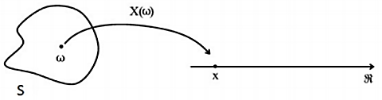
Random Variable: Mapping between all the outcomes in the sample space w. a set of real numbers; Denoted using capital letters; ¹Discrete Random Variables: Only countable number of values; Probability Distributions: All possible values of a discrete random variable w. their corresponding probability values; Also known as probability mass function (p.m.f.); Denoted by $P_{X}(x)$; Properties: $P_{X}(x)$ refers to $P(X=x)$; Probability distribution function is always non-negative; $\sum_{all X}{P_{X}\left(x\right)=1}$; Cumulative distribution function (c.d.f.) $F$ of the random variable $X$ is defined by: $F_{X}\left(x\right)=P(X≤x)$; Adding probability values; Expected value: Same as mean of the random variable; Let $X$ be a discrete random variable with p.m.f. $P_{X}(x)$. Then the expected value of $X$, denoted by $E(X)$, is defined by: $E\left(X\right)=\sum_{all x}{(x}⋅P(X=x))$; Properties: $E(c)=c$; $E\left[g\left(X\right)\right]=\sum_{all x}{[g(x)}⋅P(X=x)]$; $E\left[g\left(X\right)+c\right]=E\left[g\left(X\right)\right]+c$; $E\left[c⋅g\left(X\right)\right]=c⋅E[g\left(X\right)]$; $E\left[X+Y\right]=E\left(X\right)+E(Y)$; $E{\left(X\right)}^{2}=E(X^{2})$; $E{\left(X\right)}^{2}=\sum_{all x}{\left(x^{2}⋅P\left(X=x\right)\right)}$; Variance: $V\left(X\right)=E{\left(X-E\left(X\right)\right)}^{2}=E{\left(X\right)}^{2}-{\left[E\left(X\right)\right]}^{2}$; Properties: $V\left(c\right)=0$; $V\left[g\left(X\right)+c\right]=V[g\left(X\right)]$; $V\left[c⋅g\left(X\right)\right]=c^{2}⋅V[g\left(X\right)]$; $V\left[X+Y\right]=V\left(X\right)+V\left(Y\right)+2Cov(X,Y)$; $V\left[X-Y\right]=V\left(X\right)+V\left(Y\right)-2Cov(X,Y)$; If $X$ & $Y$ are independent then, $Cov\left(X,Y\right)=0$; Standard Deviation: $\sqrt{Variance}$; Covariance: Measure of how the changes in one variable are associated w. the changes in second variable; How 2 random variables vary together; $Cov\left(X,Y\right)=E\left\{\left[X-E\left(X\right)\right]⋅\left[Y-E\left(Y\right)\right]\right\}=E\left(XY\right)-E\left(X\right)⋅E(Y)$; Join Probability Mass Function: If discrete random variables $X$ and $Y$ are defined on the same sample space ($S$), joint p.m.f is given by: $P(x, y) = P(X = x and Y = y)$; Under following conditions: $0≤P\left(x,y\right)≤1$; $\sum_{all x}{\sum_{all y}{P\left(x,y\right)=1}}$; Discrete Probability Distributions: Binomial Distribution: Expansion of Bernoulli distribution; Each trial has a Bernoulli distribution;
Bernoulli’s Distribution | Binomial Distribution | Poisson Distribution
Only 2 possible outcomes (success/failure)
Only 1 trial | # of trials ($n$) are fixed | Trials ($n$) is large
 | Probability of success ($p$) is constant for each & every trial | Occurrences are independent of each other
 | Trials are independent | [Assume that # of occurrences in disjoint intervals]
Tossing a coin once | Tossing a coin 10 ($n$) times | # of defects in a lot
$X-$ Getting the success | $X-$ # of successes in $n$ # of trials | $X-$ # of occurrences for given rate of occurrence ($λ$)
$X\sim$Bernoullie($p$) | $X\sim$Bin($n,p$) | $X\sim$Poisson($λ$)
$$P_{X}\left(x\right)=p^{x}{\left(1-p\right)}^{1-x}$$  [p.m.f] | $$P_{X}\left(x\right)=\left({n \atop x}\right)p^{x}{\left(1-p\right)}^{n-x}$$  x = 0,1,2,…,n [p.m.f] | $$P_{X}\left(x\right)=\frac{e^{-λ}λ^{x}}{x!}$$  x (upper bound) = 0,1,2,… [p.m.f]
$$E\left(X\right)=p$$ | $$E\left(X\right)=np$$ | $$E\left(X\right)=λ$$
$$V\left(X\right)=p(1-p)$$ | $$V\left(X\right)=np(1-p)$$ | $$V\left(X\right)=λ$$
Poisson Approximation: If $X∼Bin(n, p)$, then $X$ can be approximated w. a Poisson distribution w. rate parameter ($λ$) being = $np$ if $p$ ↓ & $n$ ↑; Usually this approximation can be used if $p<0.1$ & $n>50$;
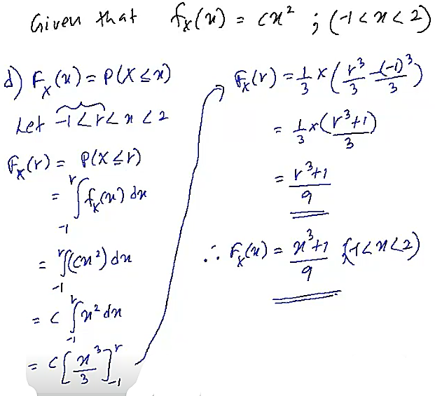
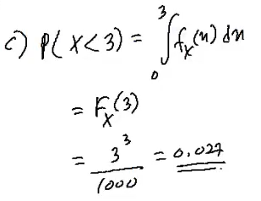
²Continuous Random Variables: Any value within a range; Measured → Continuous Data; Counted → Discrete Data; If $X$ is a continuous random variable, $P(X=a)=0$ for any value of $a$ (because there are infinite possible points for it to land on, so, probability = 0); Probability Distribution: Can’t be presented in a tabular form (table format); Probability distribution function of a continuous random variable → probability density function (pdf); Area under p.d.f. gives probability values; Properties: Function $f_{X}(x)$ is a probability density function for continuous random variable $X$, defined over the set of real numbers ($R$), if: $f_{X}\left(x\right)≥0$, for all $x∈R$; $\int_{-∞}^{∞}{f_{X}\left(x\right)dx=1}$; $P\left(a<X<b\right)=\int_{a}^{b}{f_{X}\left(x\right)dx}$; Cumulative Distribution Function (c.d.f): Represents total accumulated probability up to point $x$; $F_{X}\left(x\right)=P\left(X≤x\right)=\int_{-∞}^{x}{f_{X}\left(x\right)dx}$; $E\left[g\left(x\right)\right]=\int_{-∞}^{∞}{g\left(x\right)f_{X}\left(x\right)dx→E\left(X\right)=\int_{-∞}^{∞}{\left(x⋅f_{X}\left(x\right)\right)dx}}$; $V\left[g\left(x\right)\right]=E\left[g{\left(x\right)}^{2}\right]-{\left\{E\left[g\left(x\right)\right]\right\}}^{2}$; Continuous Probability Distributions: Uniform Distribution: Simplest probability distributions in statistics; Let $X$ is a continuous random variable taking values in the range of $a$ & $b$ follows a uniform distribution. Then it can be represented as: $X∼U(a, b)$; $a$ – lower limit; $b$ – upper limit; W. probability density function given by: $f\left(x\right)=\left\{\begin{aligned}\frac{1}{b-a} if a≤x≤b otherwise \\ 0\end{aligned}\right.$; $P\left(x_{1}<X<x_{2}\right)=\frac{x_{2}-x_{1}}{b-a}$; Then, $E\left(X\right)=\frac{b+a}{2}$; $V\left(X\right)=\frac{{\left(b-a\right)}^{2}}{12}$; Standard uniform distribution: Uniform distribution where $a = 0$ & $b = 1$; Here, $E\left(X\right)=\frac{1}{2}$; $V\left(X\right)=\frac{1}{12}$;
Exponential Distribution | Normal/Gaussian Distribution
To model life times  (link to Poisson) | Commonly used; Bell shaped & perfectly symmetrical around $μ$
$$X\sim Exp(λ)$$ | $$X\sim N(μ,σ^{2})$$
$$f_{X}\left(x\right)=\left\{\begin{aligned}λe^{-λx} \\ 0\end{aligned}{x≥0 \atop otherwise}\right.$$ | $$f_{X}\left(x\right)=\frac{1}{σ\sqrt{2π}}\exp\left[-\frac{{\left(x-μ\right)}^{2}}{2σ^{2}}\right], -∞<x<∞$$
$$E\left(X\right)=\frac{1}{λ}$$ | $$E\left(X\right)=μ$$
$$V\left(X\right)=\frac{1}{λ^{2}}$$ | $$V\left(X\right)=σ^{2}$$
Exponential Distribution: Widely used in waiting line (queuing) theory to model the length of time between arrivals in process; Battery’s lifetime; Decaying graph; $\int_{b}^{d}{e^{ax}dx={\left[\frac{e^{ax}}{a}\right]}_{b}^{d}};$ Standard Normal Distribution: Normal distribution w. $μ=0$ & $σ^{2}=1$; Evaluating probabilities w. Normal requires complex integration; To simplify the procedure, statistical tables are defined; But tables for each combination of $μ$ & $σ^{2}$ can’t be created; So, tables are only for standard normal distribution; Normal → Standard Normal, if $X\sim N(μ,σ^{2})$, then, $Z=\frac{X-μ}{σ}\sim N(0,1)$; Approximating Binomial Probabilities: Normal distribution → For $X∼Bin(n,p)$, this approximation can be used if $n$ is large & $p$ is moderate; General rule can be defined as, $np$ & $n\left(1-p\right)>5$; Can be approximated w. r.v. w. a distribution $Y\sim N\left(μ=np,σ^{2}=np\left(1-p\right)\right)$; Mean & variance of Binomial; Continuity correction is needed because a discrete distribution is approximated w. a continuous distribution; Continuity Correction: If $X∼Bin(n,p)$ is approximated w. a r.v. $Y∼N(np,np(1-p))$, $P(X≤a)=P(Y<a+0.5)$; $P(X<a)=P(Y<a-0.5)$; $P(X≥a)=P(Y>a-0.5)$; $P(X>a)=P(Y>a+0.5)$; $P(X=a)=P(a-0.5<Y<a+0.5)$; Approximating Poisson Probabilities: Normal Distribution → If $X∼Poisson(λ)$ then if$λ>20$, the approximation can be used; Can be approximated w. r.v. w. a distribution $Y\sim N(μ=λ,σ^{2}=λ)$; Mean & variance of Poisson; Continuity correction is needed because a discrete distribution is approximated w. a continuous distribution (same as binomial → normal approximation);
Simple Random Sampling (SRS): Starting point for all probability sampling designs; Each unit in population ($N$) has same chance of being selected to the sample ($n$); Sampling may be done w. or w/o replacement (SRSWR or SRSWOR); SRSWOR yields more precise results & is operationally more convenient; SRS is a set of independent & identically distributed (iid) observable random variables; Sampling Distribution: Probability distribution of a statistic (summary characteristic of sample); Let $X_{1}, X_{2},…, X_{n}$ be a random sample of size $n$ from a population with mean $μ$ & variance $σ^{2}$. Then, $E\left(\overline{X}\right)=μ$; $V\left(\overline{X}\right)=\frac{σ^{2}}{n}$; Standard Error (SE): Standard deviation of a sampling distribution; $SE=SD=\frac{σ}{\sqrt{n}}$; Although r.v.s are identically distributed, a specific distribution type is not needed; Let $X_{1},X_{2},…,X_{n}$ be a random sample of size $n$ from a normal population w. mean $μ$ & variance $σ^{2}$. Then, $\overline{X}\sim N\left(μ,\frac{σ^{2}}{n}\right)$; Central Limit Theorem (CLT): Let $X_{1},X_{2},…, X_{n}$ be a large random sample of size $n$ from a population w. mean $μ$ & variance $σ^{2}$. Then, $\overline{X}\sim N\left(μ,\frac{σ^{2}}{n}\right)$; Sample size $n$ must be at least 30; Central Limit Theorem can be applied regardless of the distribution of the population;
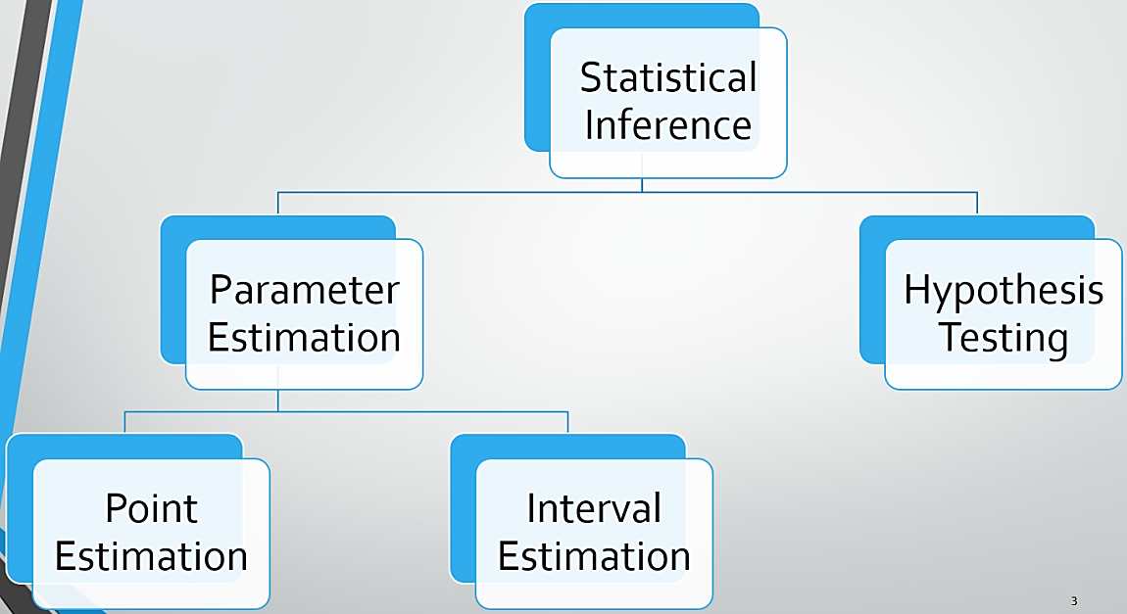
Statistical Inference: In most research, sample survey is collected over a census; Statistical inference is used when sample survey is conducted over a census; Inference: A conclusion reached based on evidence & reasoning; Statistical Inference: Drawing conclusions about population parameters by using sample statistics; Parameter Estimation:

